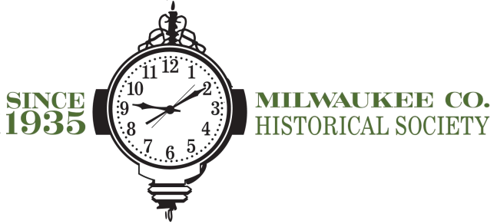
Preservation Education Experience Program INTERN
APPLICATIONS WILL BE REVIEWED IMMEDIATELY

The Milwaukee County Historical Society, a 501c3 non-profit organization, is looking to fill the Preservation Education Experience Program (PEEP) intern position. The PEEP Intern would report to the Event & Volunteer Coordinator and Executive Director.
PEEP is a new addition to the programmatic and educational offerings of the Milwaukee County Historical Society. It is as a way to build appreciation for historic buildings, to gain restoration experience, while also helping to preserve our five historic sites throughout Milwaukee County. These are meant to be hands-on opportunities for participants to actively protect history through the preservation of our properties.
The primary responsibility of this position will be to act as the lead coordinator of the Preservation Education Experience Programs including, finalizing the dates, developing the scope of each project, developing partnerships, and recruiting and managing volunteers.

Individuals working towards degrees in Architecture, Historical Preservation, Museum Studies, or other related fields are encouraged to apply.
Hours are flexible. Some evening and weekend availability is required.

To apply, please submit a cover letter, resume, and three references to:

Mary Jo Knapp
Educator
910 N. Old World Third St
Milwaukee WI, 53203
abalistreri@milwaukeehistory.net
414-273-8288 ext. 19

