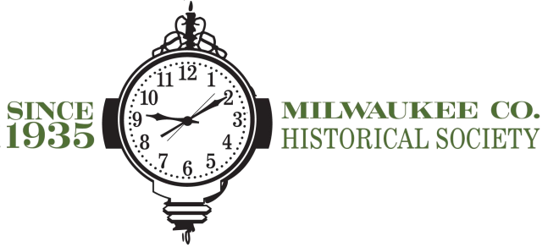
Special Events: General
INTERN
APPLICATIONS WILL BE REVIEWED IMMEDIATELY

The Milwaukee County Historical Society, a 501c3 non-profit organization, is looking to fill the Special Events Intern position. The Special Events Intern would report to the Event & Volunteer Coordinator and Executive Director.
The primary responsibility of this position will be to assist in the development and management of both large and small scale events including, but not limited to:
Exhibit-based events (January-April)
Annual Awards Dinner (May)
Harvest of Art & Crafts (September)
Individuals with backgrounds in History, Anthropology, Museum Studies, Communications, and Event Planning are encouraged to apply.
Hours are flexible. Evening and weekend availability is required.
Semester and year-long internships are available. Can be completed for credit.
To apply, please submit a cover letter, resume, and three references to:
Mary Jo Knapp
Educator
910 N. Old World Third St
Milwaukee WI, 53203
mjknapp@milwaukeehistory.net
414-273-8288 ext. 19

