History at Home
with the
Milwaukee County Historical Society
Mary Jo Knapp
Family Activities First People Activity
Paleo/Archaic Period
Paleo 10,000 BC- 6,500 BC- Archaic period 6,500 BC – 800 BC
Here are some entertaining websites you may want to share with your student.
https://www.wisconsinhistory.org/kids/mammoth/main.html The Mammoth Mystery online interactive archeological site
https://museums.kenosha.org/public/exhibits-2/mammoths-kenosha-public-museum/

Native Americans made everything they needed by using animals or natural resources that surrounded them. While you are walking the neighborhood, find natural resources in your neighborhood, and figure what you could make with them. What would you use for clothing, shelter, food, tools, and transportation?

Important take-aways- What they hunted- Native Americans would use all of the animal that they could. Native Americans only hunted as much as they needed by showing respect and honor to the animals. No waste!
How can you change your habits to reduce the amount of waste you create?

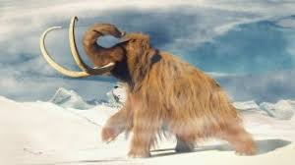
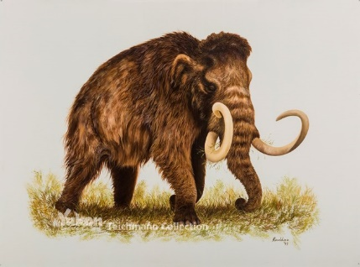
History at Home
with the
Milwaukee County Historical Society
Mary Jo Knapp
Family Activities First People Activity
Woodlands 800 BC – 1630 AD Mississippians- 1,000 AD – 1,200 AD Oneota 1,000-1,630 AD
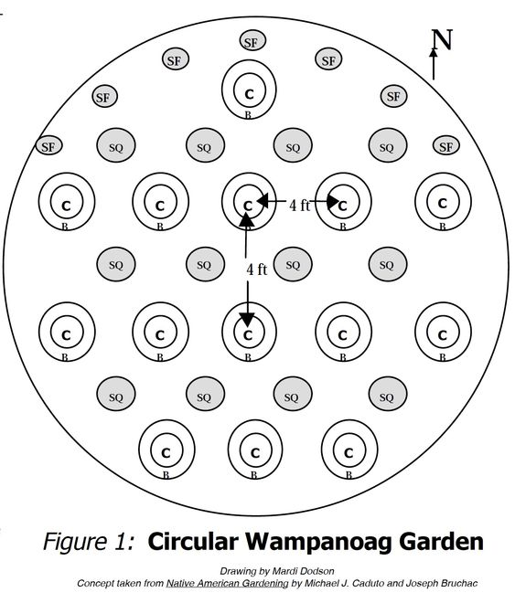
3 Sisters- Corn, Squash, Beans
These were three of the most common crops that
Native Americans planted.
Corn- Upright stalks – pole-like structure for beans to grow on.
Good for carbohydrates
Beans- help create the soil rich with nitrogen. Good for protein.
Squash- large leaves shade the soil, preventing the moisture
from leaving soil. Its stems and leaves are “prickly” discouraging animals from eating the plants. Good for vitamins.
Polycultural planting is more resilient than planting just one crop.

Does your family have any corn, beans, or squash at home? Can you plant the seeds or watch them sprout in a Ziploc bag? https://lifeovercs.com/germinating-seeds-bag-science-experiment-kids/
What kind of food would you like to plant? Can you plant some food seeds indoors? Plan an outdoor garden with foods that your family eats often.

History at Home
with the
Milwaukee County Historical Society
Mary Jo Knapp
Family Activities First People Art and Visit Activities
Woodlands 800 BC – 1630 AD Mississippians- 1,000 AD – 1,200 AD Oneota 1,000-1,630 AD

Pottery- clay from a water source.
https://www.allrecipes.com/recipe/240641/salt-dough/
Using the recipe above, try to make a useful pot. They would need to dry it and then would typically decorate it.

Making Music
Wisconsin Indians would have used many different materials to make instruments. They would use wood, animal skins, and plants like squash. Can you try to make a drum, flute or a maraca with materials from home? What did you use? Share a picture with someone you love.

Aztalan Visit
When this crisis is over, there is a park in Jefferson County to visit the ancient Effigy Mounds that were created by the Mississippian Indians. https://dnr.wi.gov/topic/parks/name/aztalan/ Aztalan site
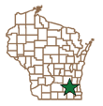
Aztalan State Park is a National Historic Landmark and contains one of Wisconsin's most important archaeological sites. It showcases an ancient Middle-Mississippian village that thrived between A.D. 1000 and 1300. The people who settled Aztalan built large, flat-topped pyramidal mounds and a stockade around their village. Portions of the stockade and two mounds have been reconstructed in the park.

Remember that Native Americans hunted for only what they needed
and they created everything that they wanted or needed.

