History at Home
with the
Milwaukee County Historical Society
Mary Jo Knapp
Family Activities Jobs That Built Wisconsin - Lead Mining
Mining was an important job that helped developed Wisconsin. It also explains why we are called the Badger State.
Miners dug in the dirt and burrowed. Early miners also dug out a home out of the earth as well, so the neighbors nicknamed them “badgers”, and the name stuck to the whole state!
Research about badgers. What do they like to eat? Find 3 new facts about them.
Can you draw a badger?
Most of the mining in Wisconsin happened between 1800-1849 and the lead mining portion was in the “Driftless Area” of Wisconsin. See if you can find it on the Wisconsin map. (SW section of WI) There was also copper and iron mines in Wisconsin as well. We know now that Lead is poisonous.
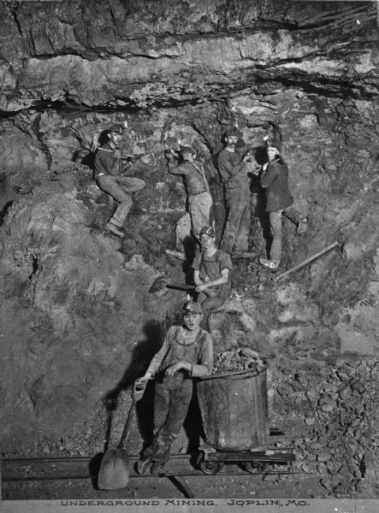
What did earlier Wisconsinites use lead for?
Miners used a windlass and a pulley system to get into and out of the
mines.
Research what a windlass and pulleys are. How are they
used? Where can you find them today?

In 1849, California had the “Gold Rush”. People all over the United States moved to California to “strike it big”. Many of our lead miners left Wisconsin and moved to California as well.
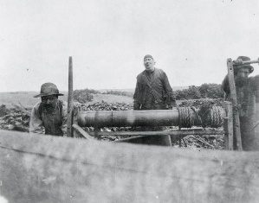
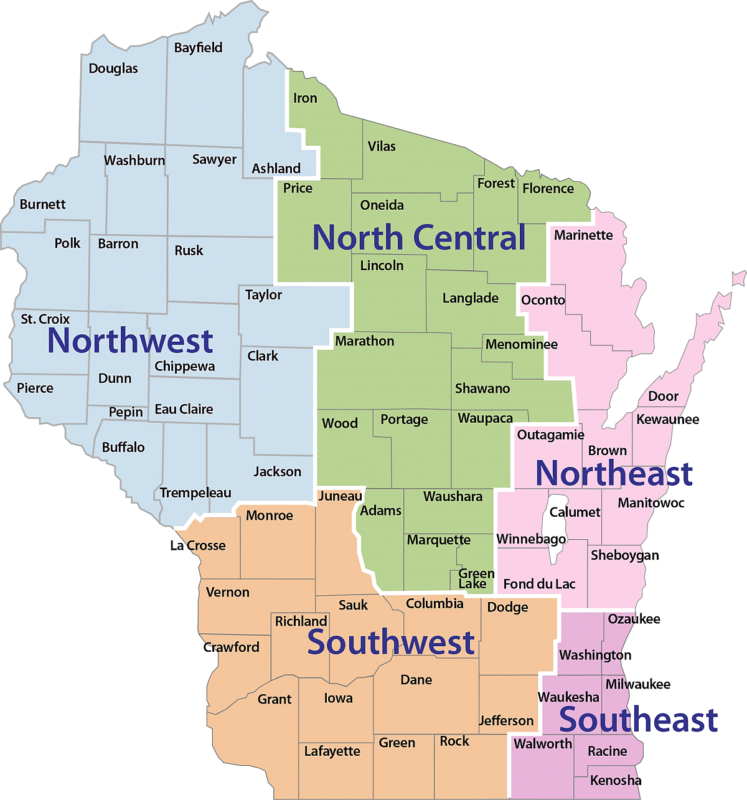
If you were a lead miner, would you have stayed in Wisconsin and mined for lead or left to go to California for gold mining?

