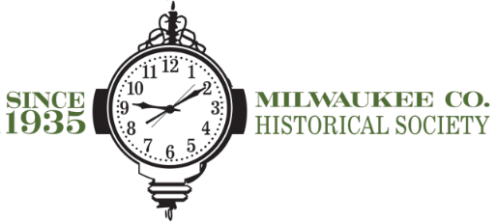

Milwaukee County Historical Society

70th Annual Awards Dinner

Wednesday, May 17, 2022

The Pfister Hotel

Sponsorship Information

You’re invited to a powerful night honoring individuals, businesses, and community organizations that have worked diligently to preserve Milwaukee County’s history and continue to forge its future.

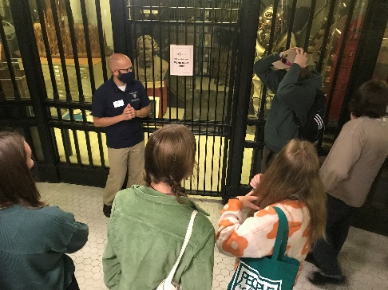When you sponsor the Annual Awards Dinner

… you honor stories.

The Historical Society stewards the items that tell Milwaukee’s story. Documents, photographs, and artifacts invite us all to learn of those who

came before us. Plus, at the event itself you will learn the stories of our Anniversary Accolade Recipients, Awardees, and County Landmarks.

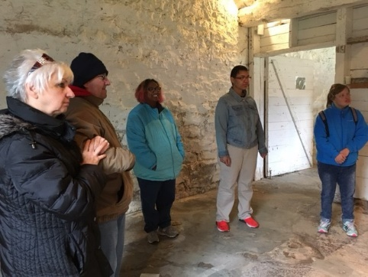… you open doors through education.

Our work allows researchers, genealogists, students of all ages, those

new to Milwaukee, longtime neighbors, and everyone in between to

explore Milwaukee County’s history, helping them find their place in it.

…you build community.

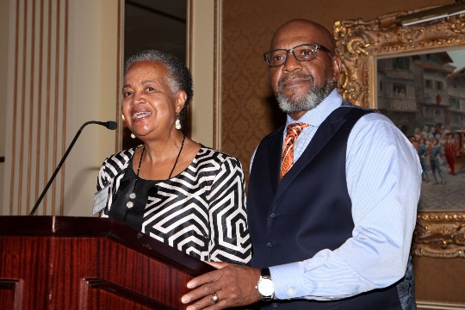All our programs encourage people to connect with various Milwaukee County spaces, organizations, and neighbors, past and present. Join us

at the 69th Annual Awards Dinner to experience this for yourself!

**We hope you will join the celebration!**

Thank you to our Presenting Sponsor, J. Jeffers & Co.

We are excited to honor Linda & John Mellowes as the   
2023 Witnesses to History, plus José A. Olivieri   
and the Menomonee Valley Partners.

Sponsorship Information

**Premier Sponsor - $5,000**

* Premier recognition on event invitation. *(provided commitment received before* ***March 10, 2022****)*
* Full page advertisement in event program. *(provided commitment received before* ***April 17, 2022****)*
* Prime recognition on signage at the event. *(provided commitment received before* ***April 17, 2022****)*
* Recognition during the event introduction.
* Two tables of 8, with recognition signage.

**Event Sponsor - $3,000**

* Logo recognition on event invitation. *(provided commitment received before* ***March 10, 2022****)*
* Logo recognition in the event program. *(provided commitment received before* ***April 17, 2022****)*
* Logo recognition on signage at the event. *(provided commitment received before* ***April 17, 2022****)*
* One table of 8, with recognition signage.

**Corporate Sponsorship - $2,000**

* Recognition on event invitation. *(provided commitment received before* ***March 10, 2022****)*
* Logo recognition in the event program. *(provided commitment received before* ***April 17, 2022)***
* Corporate listing on signage at the event. *(provided commitment received before* ***April 17, 2022)***
* One table of 8, with recognition signage.

**Civic Table Sponsorship (Available to Non-Profit Groups & Community Supporters) - $1,000**

* Recognition in event program. *(provided commitment received before* ***April 17, 2022****)*
* One table of 8, with recognition signage.

**Additional Seats Available: Individual $100, Milwaukee County Historical Society Member $95**

All Sponsors also receive a one-year membership to the Milwaukee County Historical Society.

**Sponsorship Authorization**

Sponsor/Organization Name:___________________________________________________________________

Please list as you would like it to appear on event signage.

Contact Name: _________________________________ Contact Phone: _____________________________

Contact Title: __________________________________ Contact Email: ______________________________

Sponsorship Level: _____________________________ Amount: $___________ # Attending:_______

Checks may be payable to the Milwaukee County Historical Society. To pay by Credit Card, contact (414) 273-8288.

Kindly return completed form and payment by **April 17, 2023.**

**By Mail:** Milwaukee County Historical Society, AAD **By Email:** info@milwaukeehistory.net

910 N Doctor Martin Luther King Jr. Dr, Milwaukee, 53203

**Thank you for supporting our work to collect, preserve, and share**

**Milwaukee County’s rich history. We are so grateful.**